ASSIGNMENT

1.Create a blog or website using Blogspot and WordPress. Customize the theme design and post new article with 500 words.

LINK:<https://interiordesigner547.wordpress.com/2023/10/17/saaru-interiors/>

LINK:[Blogspot](https://saaruinc.blogspot.com/2023/09/the-foodie-chronicle.html)

2. Create a New Facebook Business Page and post one

social media poster for your brand.

LINK: [Facebook](https://www.facebook.com/mystyleprodut/)<https://www.facebook.com/Saaru.inc>

3. Create and design a social media advertisement poster

using canva.

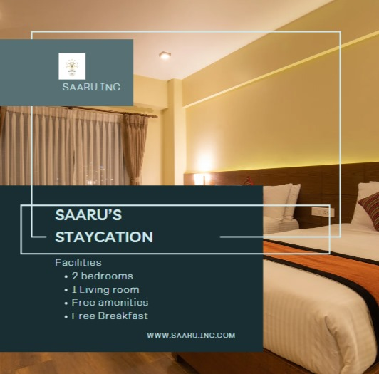

4. Create email newsletter design using MailChimp or canva

tool.

